Unit 7: My Neighborhood

1. **Getting Started** (p. 63)

Match the names of places found in a neighborhood with the pictures.

1. grocery store
2. stadium
3. wet market
4. drugstore
5. hairdresser’s
6. swimming pool
7. **Listen and read (p. 63)**

* hairdresser’s (n): tiệm cắt tóc
* stadium (n): san vận động
* wet market (n): chợ cá tươi
* serve (v): phục vụ, dọn thức ăn

service (n): sự phục vụ

servant (n): người hầu

* pancake (n): bánh xèo
* area (n): khu vực, vùng
* delicious (adj): thơm ngon, ngon tuyệt
* taste (v, n): nếm, có vị

tasty (adj): đậm đà

* close by: gần

**Complete the sentences. Use the words from the dialogue (p. 64)**

1. Na is **new** to the neighborhood.
2. She and her family arrived **last week**.
3. Na's mother is very **tired**.
4. There is a **restaurant** in the area.
5. The restaurant serves food from **Hue**.
6. Nam thinks the **pancakes** are tasty.
7. **Speak (p. 64-65) Học sinh tự thực hiện**

* parcel (n): bưu kiện gói
* airmail (n): thư, bưu phẩm gửi = đường hàng không
* surface mail (n): thư, bưu phẩm gửi = đường bộ
* weigh (v): cân weight (n): trọng lượng
* charge(n): phí tổn, tiền phải tra
* brochure (n): sách nhỏ thông tin hay quảng cáo

**Look at the following brochure and the information in the box. Make similar dialogues. (p. 65)**

**Kon Tum**

**Clerk:** Can I help you?

**You:** I'd like to send this letter to Kon Tum.

**Clerk:** Do you want to send it airmail or surface mail?

**You:** I'm not sure. How much is surface mail?

**Clerk:** I'll have to weigh the letter first. Well, 20 grams. That'll be 800 dong.

**You:** OK. I'll send it surface mail.

**Clerk:** All right.

**Ho Chi Minh**

**Clerk:** Next, please.

**You:** I want to send this postcard Ho Chi Minh City.

**Clerk:** Do you want to send it airmail or surface mail?

**You:** I'm not sure. How much is airmail?

**Clerk:** I'll have to weigh the postcard first. Well, 15 grams. That'll be 1,200 dong.

**You:** OK. I'll send it airmail.

**Ca Mau**

**Clerk:** Can I help you?

**You:** I'd like to send this pareel to Ca Mau.

**Clerk:** Do you want to send it airmail or surface mail?

**You:** I'm not sure. How much is airmail?

**Clerk:** I'll have to weigh the pareel first. Mnn. Two kilograms. That'll be 13,000 dong.

**You:** Ok! That's not very expensive. I'll send it airmail.

**Buon Ma Thuot**

**Clerk:** Can I help you?

**You:** I'd like to send this pareel to Buon Me Thuot.

**Clerk:** Do you want to send airmail or surface mail?

**You:** I'm not sure. How much is airmail?

**Clerk:** I'll have to weigh the parcel first. Mmm, five kilograms. That'll be 32,000 dong.

**You:** Oh! That's expensive.

**Clerk:** Surface mail is much cheaper. It's only 19,200 dong.

**You:** That's better. I'll send it surface.

**Clerk:** All right.

1. **Listen (p. 65-66)**

* Kick off = start

**Listen to the conversation. Then fill the blank in each of the advertisement with one phrase from the box. (p. 66)**

Millennium Cinema: (1) *The Newcomer*

Soccer: (2) *Town Ground*

(3) *English Speaking Contest*

Photo Exhibition: (4) *Culture House*

**Listen to the conversation again and check (V) the correct box for True, False or No Information. (p. 66)**

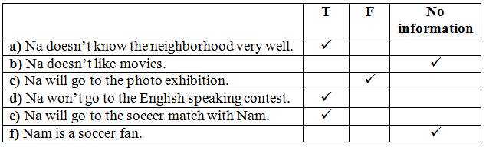

1. Write: (p. 68) học sinh tự học

**Use the similar format to write a notice about the English Speaking contest below. (p. 68)**

The school English Speaking Club is going to hold a speaking contest to celebrate the Teachers'Day. The contest will be at Hall 204, Building G, from 7.30 pm to 10.00 pm on November 15. The person to contact is Tran Thi Thu Hang of class 8H.

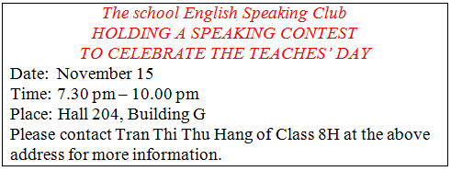

**Write one or two notices about your class meeting and / or your Sports Club meeting. (p. 68)**

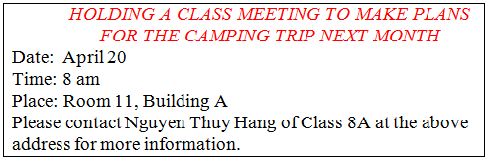

1. Homework

* Learn new words
* Prepare Unit 7 (read, language focus)